Bo Lin

**ECE 579 Digital Control Systems**

Test 1

Note: Computer generated report is required for the test.

Name: Bo Lin Grade: _____________

**Report: (20)**

**1. (30) (Root Locus)** **The block diagram shows a simplified form of** **roll control for an airplane. Overall system specifications with a step input are ts<1.0sec and Mp<30%. Ah is the gain of an amplifier in the H2 feedback loop. G2=A2 is an amplifier of adjustable gain with a maximum value of 100. Restrict *b* to value between 15 and 50.**

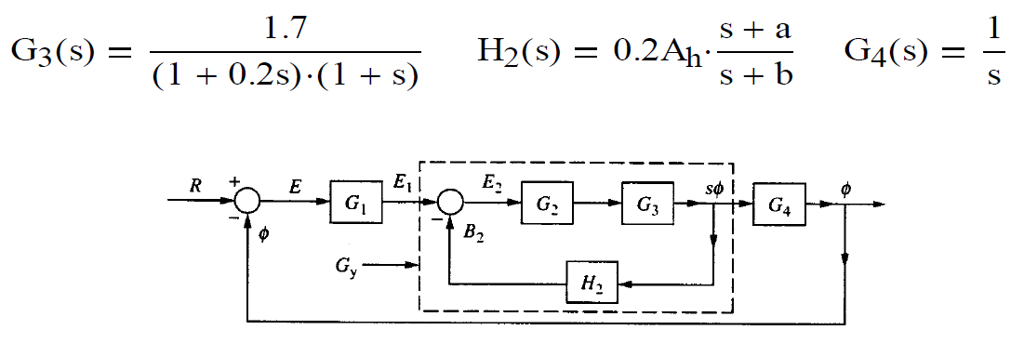

**a) With G1(s)=1, determine a set of parameters Ah, a, and b in H2(s) to meet the overall system specifications. Verify your design with simulation (Simulink required, m-file optional). Determine the figures of merit (Mp, tp, and ts) for the overall closed-loop system.**

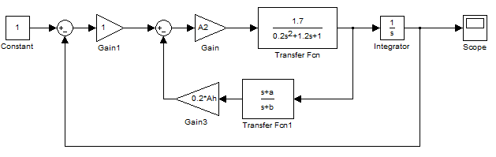

Figure Original System Block Diagram

First, we can transfer the system to a simpler system:

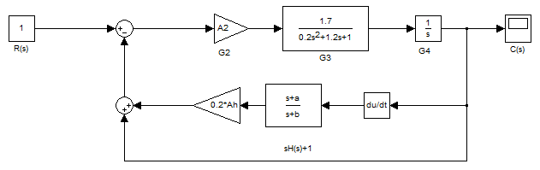

Figure Simplified System Block Diagram





The Characteristic equation Gx(s)H(s), we have n=4 finite poles and m=2 finite zeroes, therefore q=n-m=2 zeroes at infinity. Angle of asymptotes are .

Considering  as K, the root locus will basically looks like:



Figure An example of system root locus

Because b is between 15 and 50, it is the furthest pole on the left. It won’t affect the system a lot. Set b=15.

Now consider the other parameters:

    


Since the numerator and denominator are factored, the roots can be obtained by plotting a root locus. The angle condition of (1+2h)180 must be satisfied for the root locus of above equation.

Using “sgrid” function to limit the .



Figure Actual system root locus with ‘sgrid’

Change the **a** and Ah to let the two zeroes to reach further left to get bigger frequency while remain in the 0.36 damping field.

After finding the right point that satisfy all the constraints, calculate A2 using Gain K.



Finally using the parameter in Simulink:

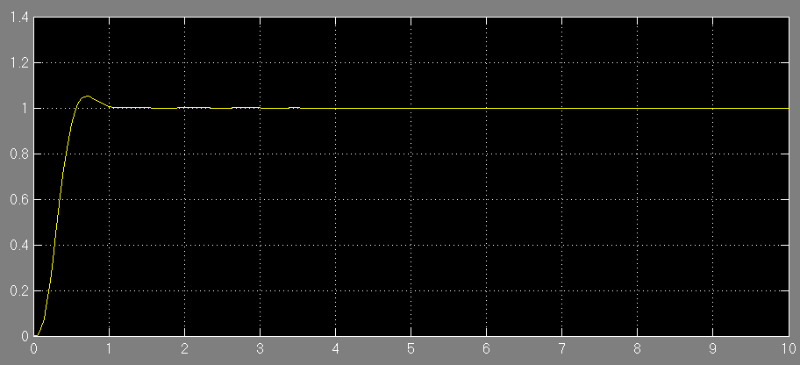

Figure The system Simulink result with designed parameters

As seen on the graph, the system meets the requirement of the question.



**b) With e1(t)=u(t), determine the values of Mp and ts for the inner-loop represented by Gy(s) (Simulink required, m-file optional).**

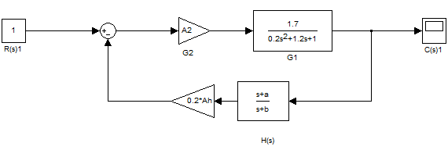

Figure 6 Inner-loop block diagram

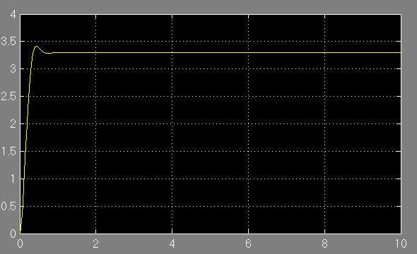

Figure Inner-loop Simulink result



Figure 8 Inner-loop root locus



**c) With A1=1 (initial value of G1) compute Kv (velocity-error constant).**



**d) Design G1(s) to increase the value of Kv by a factor of 5 while maintaining the desired overall system specifications.**

Design G1(s) to be a lag compensator to meet the requirement.



If Kv increases by a factor of 5, that means if A=1, z/p=5

So,

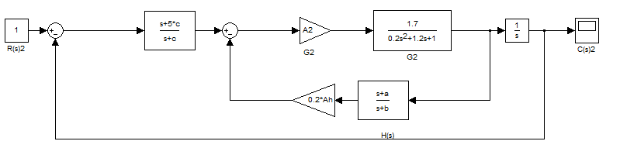

Figure System with lag compensator block diagram



Figure 10 Root locus without lag compensator

As we know the ratio of z and p already, the only requirement is to meet the angle condition:

 .

In order to maintain the location of the locus,



In order to achieve the equation above, the lag compensator should be as close to imaginary axis as possible. However, it should not be too close to the imaginary axis because it’s hard to implement.

So choose for zero location.

The real part of dominant pole is 5.06, so the zero is 0.1.

So c=0.02.



The new result and compared result are shown below:

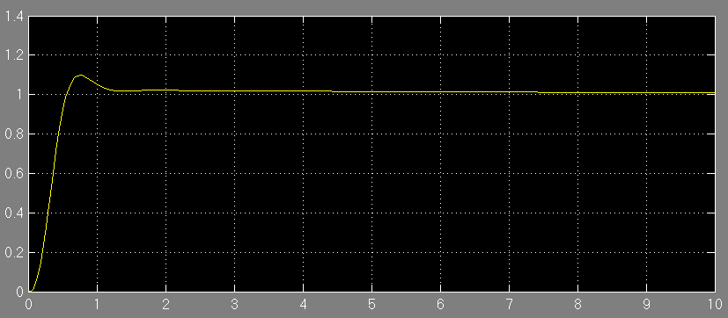

Figure Simulink result after adding lag compensator

**e) Verify your design of part (d) with simulation (Simulink required, m-file optional). Determine the figures of merit for a step input and compare them with a) (Simulink required, m-file optional).**

As we can see, since the root locus shape doesn’t change much, the performance is very similar. The new design with a lag compensator has a little bigger over shoot and steady-state error. That is due to the increase of Kv.

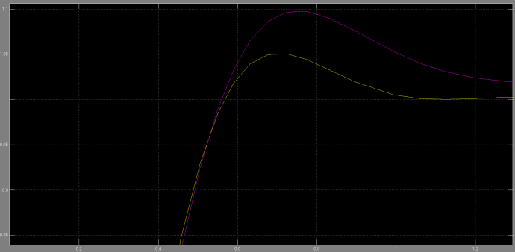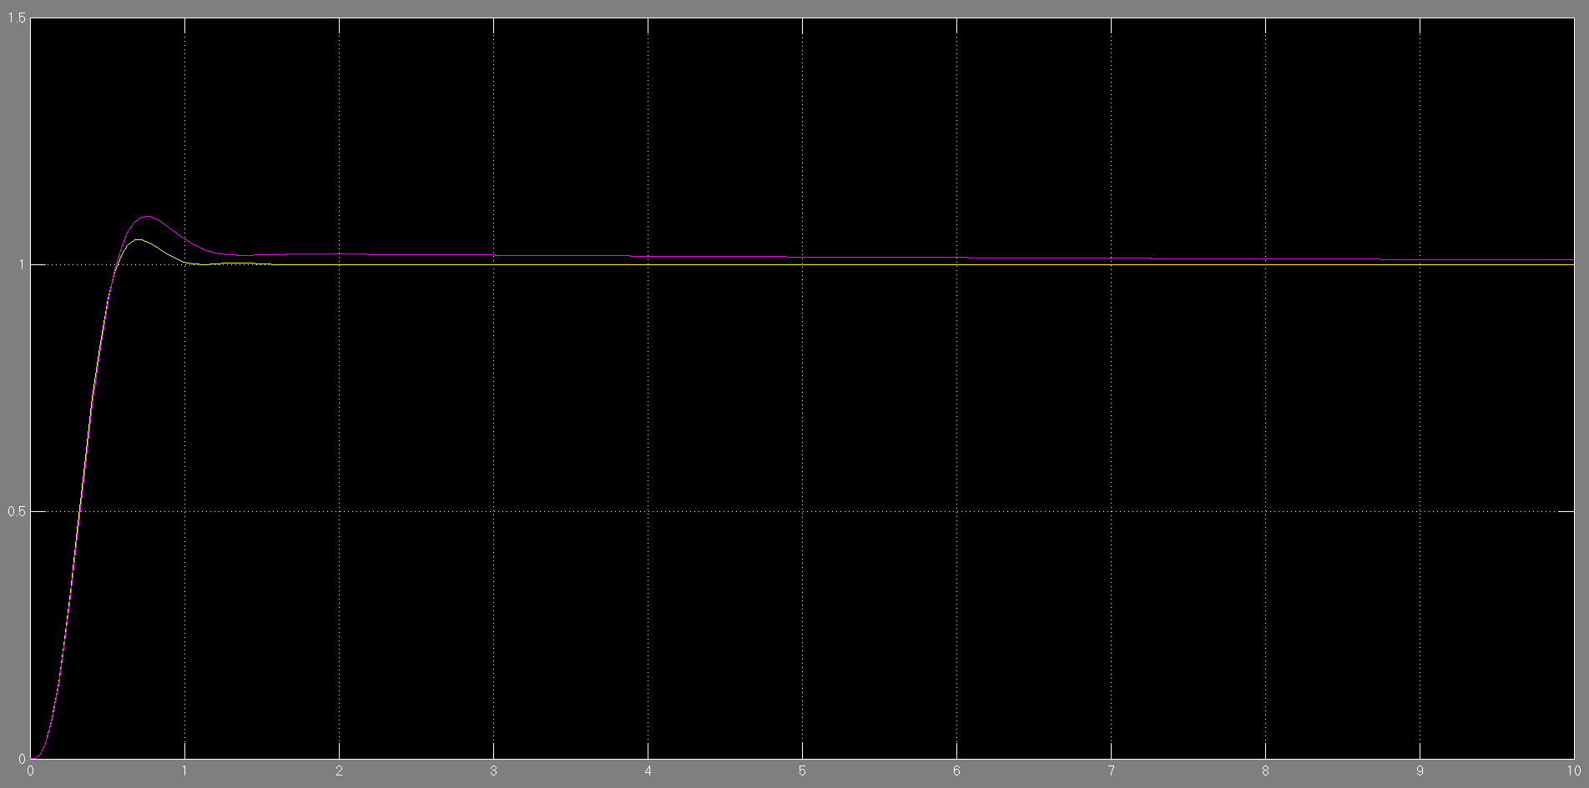

Figure 12 Compare of part a and part d under step input

+

**f) Compare a) and d) for the system performance under ramp input.**

**The system with lag compensator has less steady-state error under ramp input.**

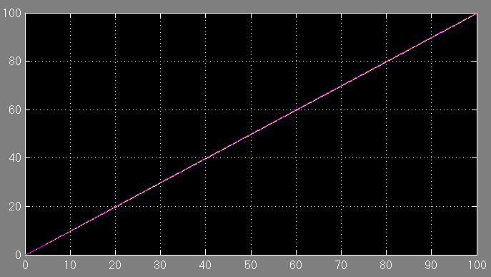

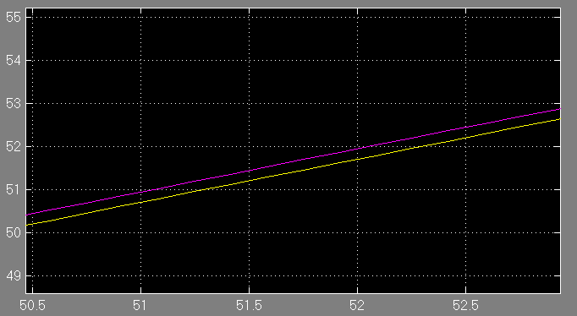

Figure Compare of part a and part d under ramp input

**2. (25) (Frequency Response) A basic (uncompensated) control system with unity feedback has a forward open-loop transfer function**

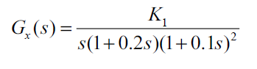

**a) For the basic system, find the gain K1 for phase margin PM=45O, and determine the corresponding phase-margin frequency** ** . Show the step response of the uncompensated system through simulation using Simulink.**

First set K=1 and see the frequency response:



Figure Original system body plot with K=1

From the Frequency Response Body plot, the Phase Margin now is 67.9 at frequency 0.972.

So with the  shift, the system will shift to the chosen point at frequency 2.03 from 0.972. The slope is 20dB/sec.





Figure First attempt of K=2.088

Due to the difference between ideal bode plot and reality, the frequency is a little short. So use the same equation and tune it again.  




Figure Second K=2.2672

The new frequency is 1.99, the PM is 45.7, it is close enough, so only need one final tune.





Figure Final value K performance in bode plot



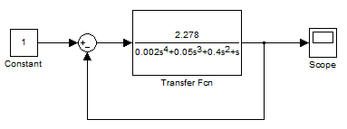

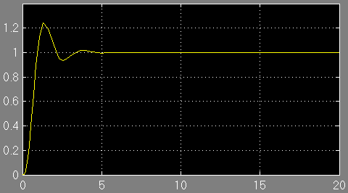

Figure Simulink result with designed K

**b) For the same phase-margin angle as in (a), it is desired to increase phase-margin frequency to a value of**** =3.0 with maximum possible improvement in gain. To accomplish this, a lead-compensator is used. Determine the value of the lead-compensator that will satisfy these requirements. Determine the new value of gain. Show the step response of the compensated system through simulation using Simulink**.

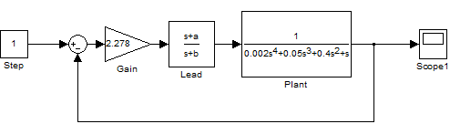

Figure System block diagram with lead compensator



In question (a), the Phase at is -154 degree, which means if choose 3 rad/sec as the phase-margin frequency, the phase needs a shift of 

-200

-150

-100

-50

0

50

Magnitude (dB)

Bode Diagram

Frequency (rad/sec)

10

-2

10

-1

10

0

10

1

10

2

10

3

-360

-315

-270

-225

-180

-135

-90

Frequency (rad/sec): 3

Phase (deg): -154

Phase (deg)

Figure 20 Original system body plot

  .

The compensator will shift the magnitude upwards by

at  .



Figure Finding the new frequency using -2.93 dB







Figure System bode plot with PM=45, w=3rad/sec

Now the only thing need to change is K. In this bode plot, K=4.





Figure Final System bode plot with PM=45, w=3rad/sec,K=5.08

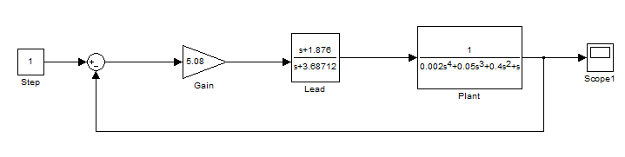

Figure Final system block diagram

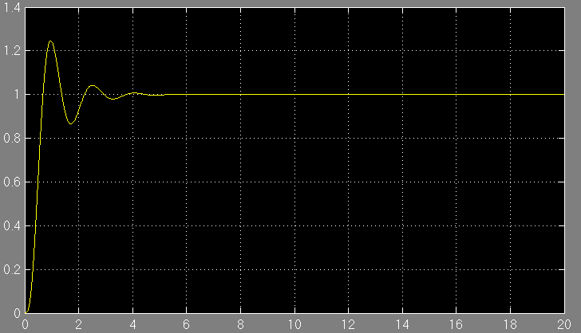

Figure Final system Simulink result

**c) Repeat part (b) with a lag-lead compensator. Show the step response of the compensated system through simulation using Simulink. Show how the compensator has improved the system performance, i.e., determine all figures of merit for each part of the problem.**

Add a lag compensator to meet the requirement.



If Kv increases by a factor of 5 like problem 1, 

As we know the ratio of z and p already, the only requirement is to meet the angle condition:

 .

In order to maintain the location of the locus,



In order to achieve the equation above, the lag compensator should be as close to imaginary axis as possible. However, it should not be too close to the imaginary axis because it’s hard to implement.

So choose for zero location.



Figure Using root locus to find lag compensator zero

The real part of dominant pole is 1.19, so the zero is 0.024.

So c=0.0048.



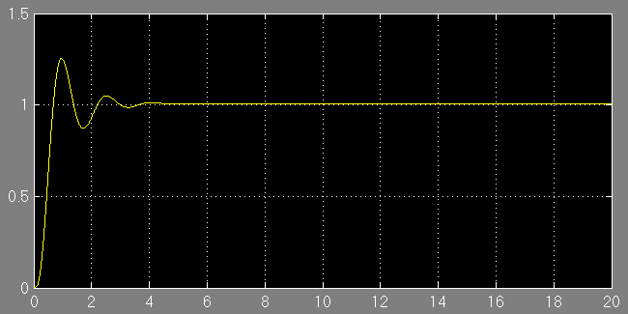

Figure 27 Lag-lead system with step input

The step input result is very similar.

Compare lead with lag-lead in ramp input. The lag-lead system has small error.

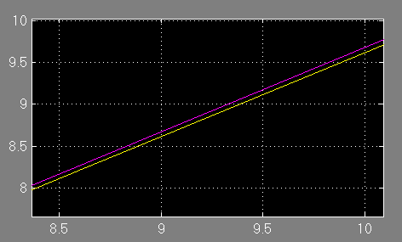

Figure 28 Lag-lead system with ramp input

**3. (25) For** 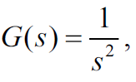

**a) design a continuous compensation so that the closed-loop system has a rise time tr<1sec and overshoot Mp<15% to a step input command. Show the step response of the compensated system through simulation using Simulink.**

The closed-loop transfer function of the system is :



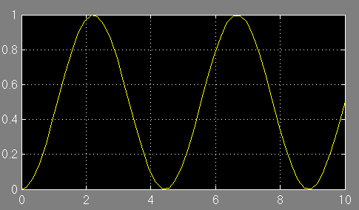

Figure Original system Simulink result







Design a phase margin of 60 degree, the procedure is similar to Project 1.



The compensator will shift the magnitude upwards by



at  .









Figure System bode plot after adding lead compensator

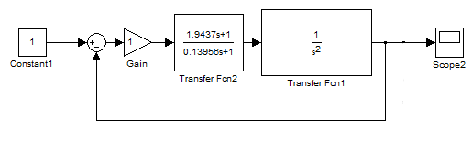

Figure System block diagram with lead compensator

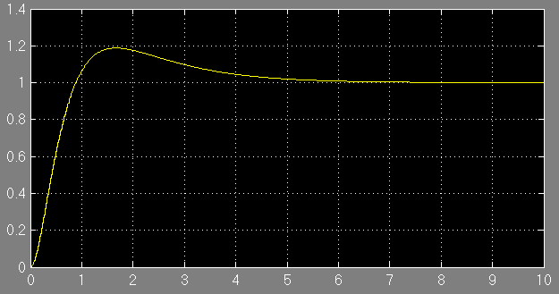

Figure System Simulink result

Conclusion: the rising time meet the requirement, but the over shoot is a little bit larger even we set the phase shift to 60. The problem is solved by using the new compensator redesigned with PM 75 in part (b).Further details will be introduced in part (b).

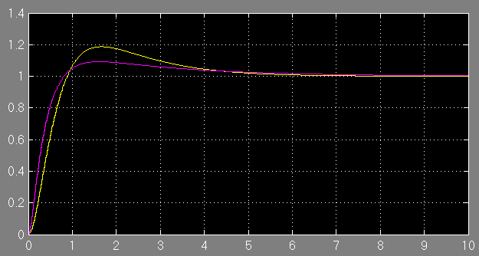

Figure 33 Compare old compensator performance with new compensator

**b)** **revise the compensation so that the specifications would still be met if the feedback was implemented digitally with a sample rate of 5Hz.**



Bode plot of the system with ZOH and without compensator:



Figure Original System bode plot with sampled feedback

If use the old compensator:

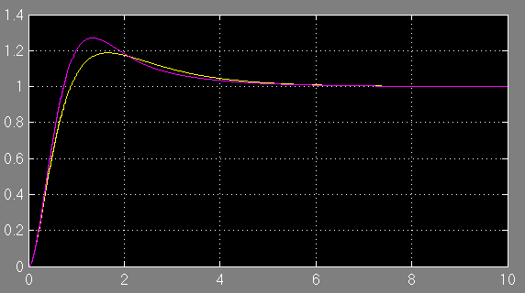

Figure Compare original and old compensator Simulink result without sampler

The over shoot is much larger due to the very low sample rate.(less than 30 times the bandwidth ,2.64rad/sec at -3dB). So the damping ratio  should be smaller to reduce the over shoot and meet the system requirement.

Bode plot of the system with ZOH and with old compensator (60 Phase shift):



Figure 36 Old compensator bode plot

From the bode plot we can see that the phase shift of the formal designed compensator still does not meet the required PM, so the compensator should be revised.

Design 



The compensator will shift the magnitude upwards by



at  .



Figure 37 New compensator bode plot







Compare (a) and (b) with digital sampler:

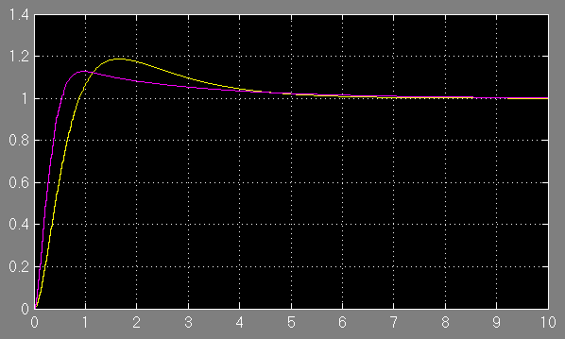

Figure Compare old and new compensator Simulink result with sampler

Conclusion: While applying sampler with low sample rate in feedback loop, the over shoot will be much higher, in order to meet the requirement, using the new compensator (line purple) with larger damping ratio will help, even there is a digital sensor in feedback loop, the performance of rising time and over shoot are better than old compensator.

**c) find difference equations that will implement the compensation in the digital computer.**



**4. (20) The one-sided z-transform is defined as**

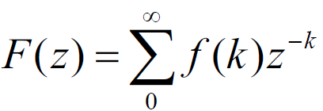

**a) Show that the one-sided transform of  is**



Proof:



**b)** **Use the one-sided transform to solve for the transformations of the Fibonacci numbers****, Let  .**

Apply z transform to the Fibonacci equation using (a) we get:



**c)** **Compute the location of the poles of the transform of the Fibonacci numbers.**



**d) Compute the inverse transform of the numbers.**

If the kth term of the Fibonacci sequence is given as



Inverse transform:



**e) Show that if uk is the kth Fibonacci numbers, then the ratio uk+1/uk will go to  , the golden ration of the Greeks.**

Assume the ratio



**f) Show if we add a forcing term, e(k), to equation** ** , we can generate the Fibonacci numbers by a system that can be analyzed by the two-sided transform; i.e., let** **and let  ( at k=0 and zero elsewhere). Take the two sided transform and show the same U(z) results in part (b).**

If it is a two sided transform,



Apply Z transform to 

Then the equation is the same transfer function as part (b).

